Reservoir Characterization Using Integration of and Model-Based Seismic Inversion and Neural Network Method, "M" Field, East Java Basin

Haiqa Sabrina Ramadhani1*, Haryono2 , Afriadhi Triwerdhana2
1 University of Indonesia, Depok, Indonesia
2 Saka Energi, Jakarta, Indonesia

*E-mail: haiqa.sabrina@ui.ac.id

Abstract. Seismic inversion is a key technique in reservoir characterization, enabling the transformation of seismic reflection data into quantitative rock property models such as acoustic impedance. This process is essential for enhancing gas field productivity by identifying reservoir features and estimating critical rock parameters. However, conventional inversion methods often struggle to accurately predict complex subsurface properties like porosity and density due to limitations in seismic resolution and the nonlinear nature of rock physics. To overcome these challenges, this study introduces an integrated methodology that combines acoustic impedance-based seismic inversion with Neural Network- driven multi-attribute analysis to evaluate a gas reservoir in the M Field, East Java Basin. Utilizing high-resolution pre-stack seismic data, the approach estimates the spatial distribution of porosity, density, and velocity. Additionally, the Neural Network analysis is employed to assess a shallower, less-explored interval, characterized by acoustic impedance values between 2948.46 and 3208.68 (g/cc*m/s), porosity levels of 18–20%, sandstone-like density ranging from 1.80 to 1.83 (g/cm³), and Vp/Vs ratios from 1.83 to 1.77. This integrated workflow enhances reservoir prediction accuracy and deepens the understanding of gas- bearing zones in the study area.

Keywords : reservoir characterization, model-based inversion, neural network multi-attribute analysis.

Introduction
Seismic inversion plays a critical role in reservoir characterization by transforming seismic reflection data into quantitative rock property models, such as acoustic impedance. However, traditional inversion techniques often face challenges in accurately predicting complex subsurface properties like porosity and density due to limitations in resolution and nonlinearity. With the advent of machine learning, particularly neural networks, new opportunities have emerged to enhance the predictive power of inversion workflows. This study presents an


Content from this work may be used under the terms of the Creative Commons Attribution 4.0 licence. Any further distribution of this work must maintain attribution to the author(s) and the title of the work, journal citation and DOI.
Published under licence by IOP Publishing Ltd 1

integrated approach that combines model-based seismic inversion and Neural Network algorithms to estimate porosity and density from pre-stack seismic high-resolution data.
The proposed methodology aims to improve the reliability and spatial continuity of reservoir properties in the Wonocolo interval in M Field, which has good gas readings and bright amplitude. This method provides a robust framework for subsurface interpretation and reservoir characterization, unlocking under-explored plays in M Field.

Regional Geology
The Muriah region, encompassing the Muriah Trough and West-15 Basin along the western margin of the East Java Basin, is recognized as one of the most geologically intricate areas among Indonesia’s back-arc basins. The sedimentary fill of the East Java Basin was shaped by Paleogene extensional tectonics followed by Neogene compressional forces.
Initial sedimentation in the Muriah area began before the Late Eocene, characterized by the deposition of coarse-grained fluvial and deltaic sediments—such as sands, conglomerates, and coal—within NE-SW oriented half-grabens, forming what is known as the Ngimbang unit. This phase ended due to either tectonic uplift, a global sea level drop, or a combination of both.
In the Late Eocene, a marine transgression led to widespread flooding and the deposition of limestones and shales of the Ngimbang Formation. However, a subsequent sea level fall and erosion likely removed parts of these deposits, especially in the Muriah area. The onset of the Oligocene brought another transgression, resulting in extensive carbonate sedimentation. In the Muriah region, marginal marine to supratidal environments may have developed during this time. This sequence was interrupted by a compressional event and a significant sea level drop around 30 million years ago, which led to erosion and the removal of much of the earlier deposits.
Sedimentation resumed in the Late Oligocene with the deposition of the Kujung III Formation, consisting mainly of continental and deltaic sediments. This renewed transgression, driven by extensional tectonics and a global sea level rise beginning around 26 Ma, gradually deepened the depositional environment, culminating in the widespread accumulation of shallow marine carbonates of the Kujung Formation during the Early Miocene.
A brief regression halted sedimentation in the Early Miocene, but deposition resumed shortly after due to a transgressive trend starting around 21 Ma. This led to the development of carbonate platforms and local buildups, followed by the deposition of marine shales from the Tuban Formation as carbonate production areas were submerged. Uplift during the early Middle Miocene caused localized erosion and structural inversion, particularly in areas with thick Paleogene sequences.
During the Middle Miocene, sedimentation was influenced by a global sea level decline and increased clastic input due to regional uplift. The Tawun Formation, composed of shales overlain by sands, reflects a shallowing environment transitioning into deltaic shoreface systems—most evident in the Muriah area. A major sea level fall around 10.5 Ma ended this phase, with erosion enhanced by ongoing tectonic activity.
In the Late Miocene, a gradual transgression once again inundated the Muriah region, leading to the deposition of the Wonocolo Formation, dominated by shales with minor limestone

interbeds. This transgressive trend continued into the Early Pliocene, marked by the accumulation of shallow marine sediments of the Ledok Formation.
A compressional phase ends this stage of deposition. However, subsequent transgression allowed the accumulation of the shallow marine limestones of the Paciran Formation during the Early to Late Pliocene. Stratigraphic chart can be shown in figure 1.
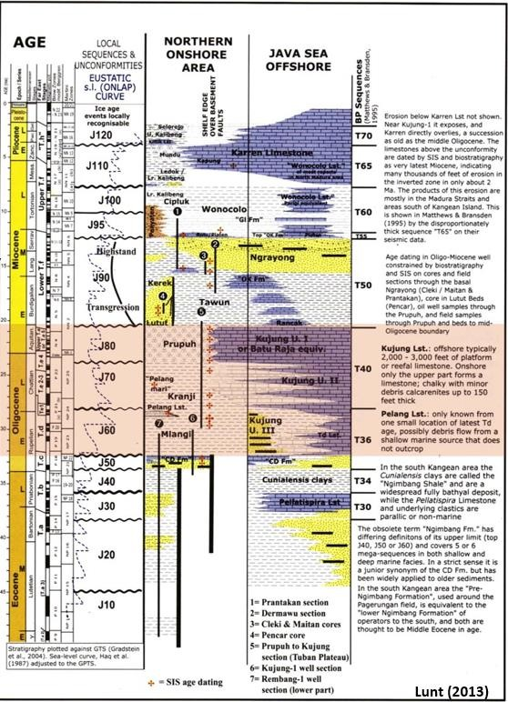
Figure 1. Regional chronostratigraphy of the study area (adapted from Lunt, 2013).

Data And Methodology Data Availability
The area of study is covered by 3D high resolution seismic survey acquired in 2022. The data was acquired by using three streamers with length 1000 meters and source depth 4 meters, with streamer spacing of 50 meters. In addition, 1 exploration well K-1 has been used in this research and yielded gas sand discovery in UTA and high gas reading in shallower part or Ledok interval. The study is located in East Java Basin shown in Figure 2.

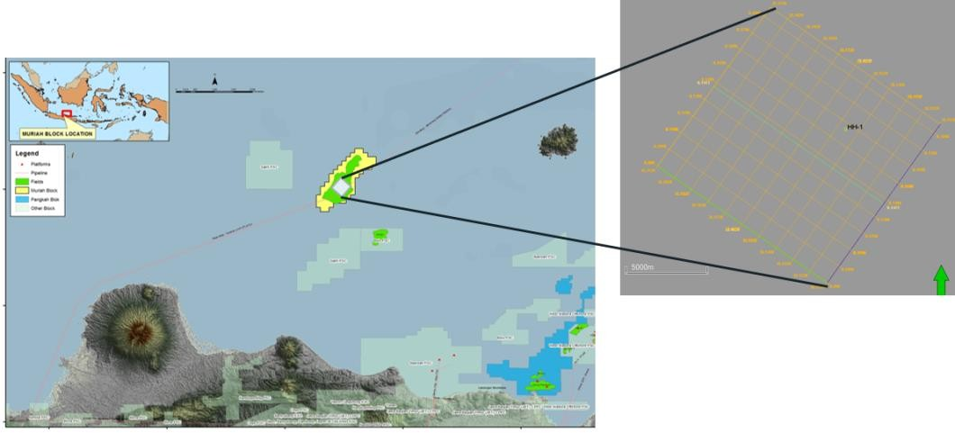
Figure 2. Location Map and Data Availability

Seismic inversion is a geophysical technique used to transform seismic reflection data into quantitative rock property models, such as acoustic impedance, density, and porosity (Russell, 1988). The methodology begins with seismic data conditioning to preserve amplitude and remove noise, followed by well log integration to calibrate the inversion process through synthetic seismogram generation and wavelet extraction. A low-frequency model, derived from well data and guided by structural interpretation, is then constructed to compensate for the band-limited nature of seismic data. The seismic inversion in this case was performed on high-resolution pre- stack seismic data, by building an initial model and generating impedance. This process is shown in figure 3.
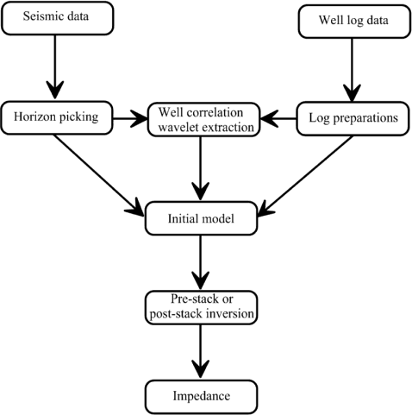
Figure 3. Illustrated workflow for the seismic inversion process (after Maurya & Singh, 2018).

The Neural Network multi-attribute analysis methodology involves using machine learning algorithms to establish nonlinear relationships between multiple seismic attributes and petrophysical properties derived from well logs. In this study, the process begins by selecting relevant seismic attributes—such as amplitude, phase, frequency, and acoustic impedance—from pre-stack seismic data that show good correlation with target reservoir properties like porosity and density. These attributes are then statistically analyzed to determine their predictive strength,

followed by normalization to ensure consistency across datasets A supervised learning model, typically a feedforward neural network, is trained using well log data as ground truth. The network learns the underlying nonlinear patterns between the selected attributes and the desired property (e.g., porosity or density) through iterative backpropagation and error minimization. Once the model is trained and validated using blind wells or cross-validation techniques, it is applied across the seismic volume to generate property prediction volumes. This methodology enables high-resolution, data-driven reservoir characterization by leveraging both seismic and well data in a predictive framework, especially in complex or under-explored intervals where traditional inversion techniques may fall short. This process is shown in figure 4.
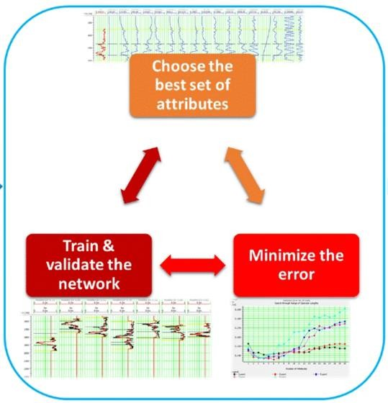
Figure 4. Diagram outlining the neural network multi-attribute analysis workflow (based on Othman et al., 2021).

Result and Discussion

Cross Plot
A cross-plot was analyzed from Well K-1 to determine gas-bearing formations. It was concluded from Figure 5 that although the separation of clusters is not very clear, a boundary could be defined to separate data indicating porous sandstone and shale in an SS-SH formation.

Table 1. Cross plot analysis

Type of Formation | Accoustic Impedance (g/cc*m/s) | Density (g/cm^3) | GammaRay (API)
Porous and saturated sandstones | 2500 – 4000 | 1.5 – 2 | 30 – 60
Saturated shale and sand sections | 3050 – 4550 | 2 – 2.5 | 50 – 70

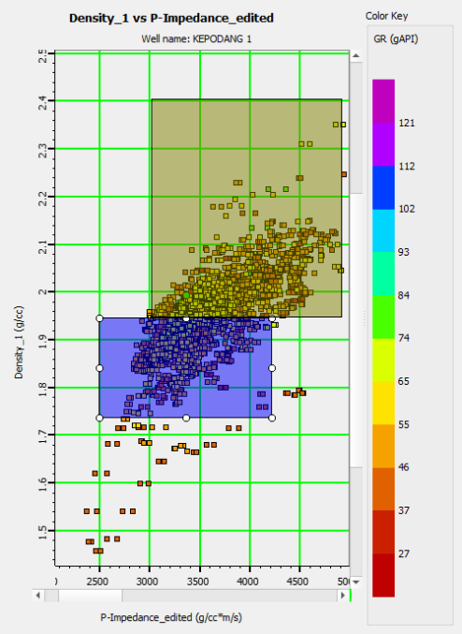
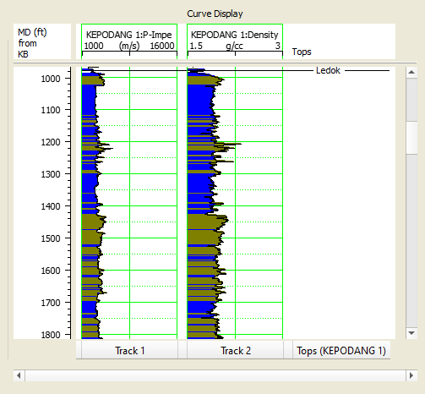

Figure 5. Cross plot AI towards Density
Ledok Formation is shown to be a reservoir with shaly sand matrix. The matrix from figure 5 is divided into two groups which are porous sandstone and shaley sand sections elaborated by table 1.

Inversion
A statistical wavelet with a dominant frequency of 33 Hz matching the amplitude spectrum of seismic data was used to tie the well to seismic. The result of the well-to-seismic tie is an absolute correlation of 0.52 and zero-time shift. Afterwards, the model-based inversion was performed with parameters including upper and lower hard constraints of 25 and 20 respectively, and a fixed iteration count of 10. The analysis of inversion demonstrated a correlation of 0.986 and 0.166 error. The inversion results are shown by figure 3.

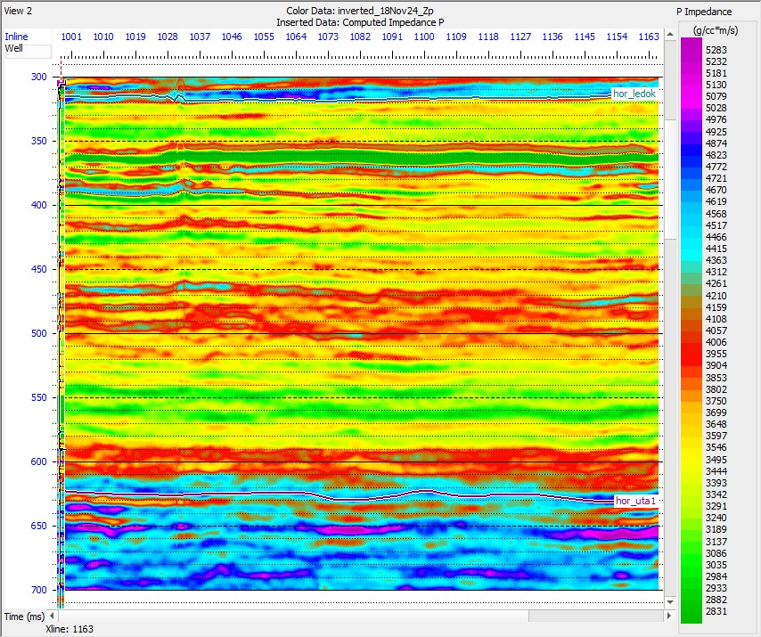

Figure 6. Model-based seismic inversion result

The reservoir target (black square in Figure 6) could be directly interpreted by referring to Table 1. The black square, with the range of 350 – 370 ms and AI range of 4057 – 2831, is porous sandstone interval.

Reservoir characterization
To fulfill the goal of reservoir characterization, this research conducted a PNN (Probabilistic Neural Network) using the EMERGE module and inversion results as input to predict porosity, density, and velocity for M Field. The results show an increase in total correlation for porosity prediction from multi-attribute analysis (0.838753) to PNN (0.853386). Correlation improved from 0.671397 to 0.877895 for density, and from 0.748173 to 0.814728 for Vp/Vs, as shown in Figure 7. The results of porosity, density, and vp/vs prediction in M-Field is shown by table 2.
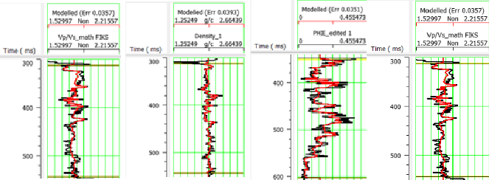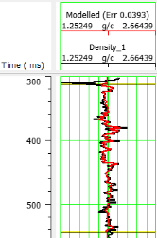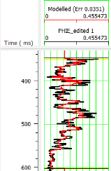
Vp/Vs
Density
Porosity
Vp/Vs
Density Porosity
Figure 7. Training (left) and validation (right) results

Table 2. Reservoir characterization

Map | Time
 | 350 ms | 360 ms | 370 ms | Scale
Accoustic Impedance | 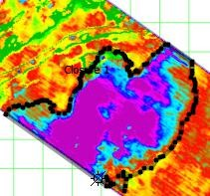 | 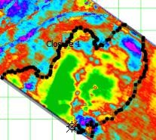 | 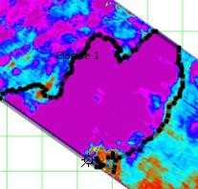 | 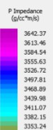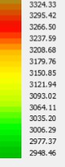
Porosity Effective | 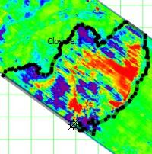 | 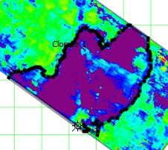 | 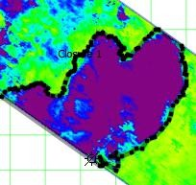 | 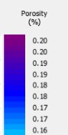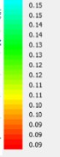
Density | 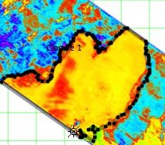 | 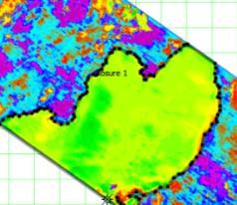 | 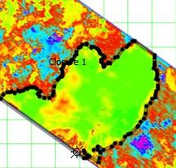 | 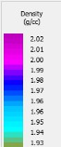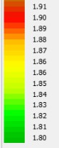
Vp/Vs | 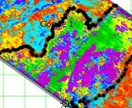 | 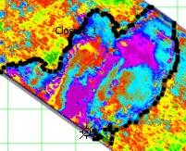 | 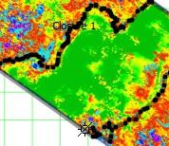 | 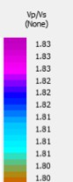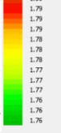
Sweetness Attribute | 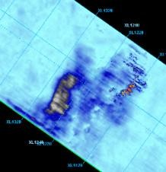 | 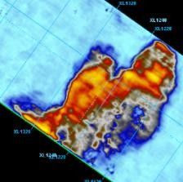 | 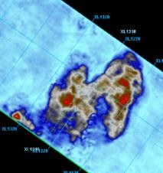 | 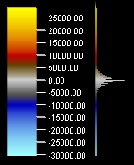
RMS  Amplitude | 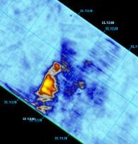 | 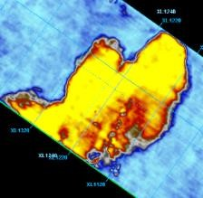 | 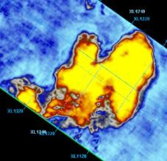 | 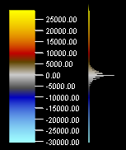

A geobody highlighted in Table 2 is analyzed on three different time slices. The first time slice, 350 ms, shows sandstone with low porosity, characterized by an acoustic impedance range of 3286.5–3642.37 (g/cm·s), a porosity range of 0–20 (%), a density range of 1.86–1.88 (g/cm³),

and a Vp/Vs range of 1.83–1.76. Time slice 360 ms shows porous sandstone with gas, characterized by an AI range of 2948.46–3208.68 (g/cm·s), a porosity range of 18–20 (%), a density range of 1.80–1.83 (g/cm³), and a Vp/Vs range of 1.83–1.77. Lastly, time slice 370 ms shows a similar range as time slice 360 ms and could also be interpreted as porous sandstone with gas. These results are validated by sweetness and RMS amplitude analysis presented in Table 2.
However, these multiple attribute properties, resulting from inversion and neural network analysis, enable the unlocking of shallow potential gas-bearing sand plays in M Field.

